Ques : Explain the below aws architecture diagram in detail, also deploy the same aws

architecture.

● For this assignment you need to take a look and study the documentation for SAM CLI,

you need to deploy a Hello, World application on aws lambda.

● Make sure when you test the lambda url it will respond as Hello, World.

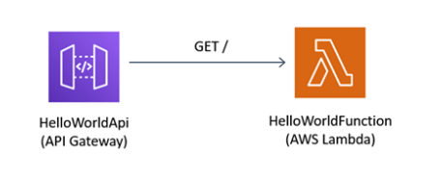

Not able to do it as I’m using office laptop  
But Able to understand architecture.

First is API gateway, when user user GET API request gateway reached to Lambda and Lambda will execute function return “HELLO WORLD”